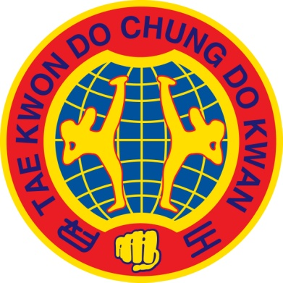
Taekwondo
Chungdokwan
Great Britain

COACH SPONSORSHIP APPLICATION

This application form is to be completed by those wishing to apply for Competition Sponsorship as a coach. Refer to ‘Competition Sponsorship Notes’ for further information.

SECTION 1 - Applicant Details
First Name(s) |  |  | Surname
British Taekwondo Membership No. |  |  | British Taekwondo Licence No.
Expiry Date (dd/mm/yyyy) |  |  | Current Grade
Club
Most recent TCGB events attended
(e.g. ‘All-In-One’ Seminar – Oct 2016)

SECTION 2 - About the Competition
Competition Name
Date(s) of Competition
Discipline for which you will provide coaching  (please tick one only) | Kyorugi (sparring) | Poomsae (patterns) | Both (Kyorugi and Poomsae)

SECTION 3 - Evidence for Sponsorship
Have you previously coached at the British Taekwondo National Championships or an A-Class (and above) competition? | Yes |  | If yes, please provide the name and date of the most recent competition
 | No
Have you applied for funding elsewhere for the same competition? | Yes |  | If yes, please name the source of funding and amount requested
 | No
Describe how coaching in this competition will enhance your Taekwondo progression and support your student’s development

(Max 200 words)
Explain precisely how any financial sponsorship would be used (please itemise the specific costs)

(Max 200 words)

SECTION 4 - Applicant Declaration
By signing this application form, you declare that the information provided is correct to the best of your knowledge and you accept the conditions upon successful sponsorship (refer to ‘Competition Sponsorship Notes’).

Print Name
Signature |  | Date

